BATTERY CHARGING

(FOR FULL SCHEMATIC PLEASE SKIP TO LAST PAGE)

**What is the charging voltage of 3.7V lithium battery?**

**(Is it ok to recharge a 3.7V with 4.2V charger?)**

* It has a nominal voltage of 3.7v and a full-charge voltage of 4.2v (as proved by our battery stress tests).
* Generally, a 3.7v lithium battery needs a “protection board” for over-charging & discharging.
* The charging cut-off voltage of 3.7V battery is 4.2V and the discharge cut-off voltage is 3.0V (therefore, when the open-circuit voltage of the battery is lower than 3.6V, it should be able to charge, but we can also charge whenever required).
* Thus it is better to use the 4.2V constant voltage charging mode, so you don’t need to pay attention to the charging time.

**Important Information from TP4056 Datasheet:**

* It is a complete constant-current/constant-voltage linear charger for single cell Lithium-ion/**Lithium Polymer** (Li-Ion/**Li-Po**) batteries.
* SOP package & **LOW EXTERNAL COMPONENT COUNT** very suitable for portability
* The charge current can be programmed externally with a single resistor.
* Automatically terminates charge cycle when required
* Includes: current monitor, under voltage lockout, automatic recharge & 2 LED supply

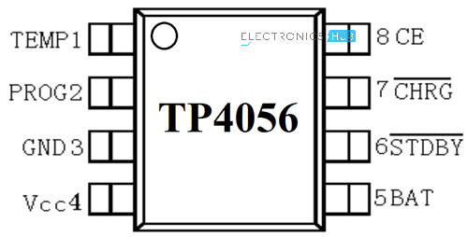**TEMP(Pin 1):** (Temperature Sense Input) Connect to NTC thermistor’s output in Lithium ion battery pack. If battery’s temperature is too high or too low, charging is suspended. **The temperature sense function can be disabled by grounding the TEMP pin.**

**PROG(Pin 2):** Constant Charge Current Setting and Charge Current Monitor Pin charge current is set by connecting a resistor RISET from this pin to GND. When in precharge mode, the ISET pin’s voltage is regulated to 0.2V. When in constant charge current mode, the ISET pin’s voltage is regulated to 2V.In all modes during charging, the voltage on ISET pin can be used to measure the charge current as follows:

**GND(Pin3):** Ground Terminal

**Vcc(Pin 4):** Positive Input Supply Voltage VIN. When VIN drops to within 30mv of the BAT pin voltage, TP4056 enters low power sleep mode, dropping BAT pin’s current to less than 2uA.

**BAT(Pin5):** Battery Connection Pin. Connect the positive terminal of the battery to BAT pin. BAT pin draws less than 2uA current in chip disable mode or in sleep mode. BAT pin provides charge current to the battery and provides regulation voltage of 4.2V.

**~~STDBY~~ (Pin6):** Open Drain Charge Status Output When the battery Charge Termination, the pin is pulled low by an internal switch, otherwise pin is in high impedance state.

**~~CHRG~~ (Pin7):** Open Drain Charge Status Output When the battery is being charged, the pin is pulled low by an internal switch, otherwise pin is in high impedance state.

**CE(Pin8):** Chip Enable Input. A high input will put the device in the normal operating mode. Pulling the CE pin to low level will put the YP4056 into disable mode. The CE pin can be driven by TTL or CMOS logic level.

HOW TO BUILD THE CIRCUIT

* 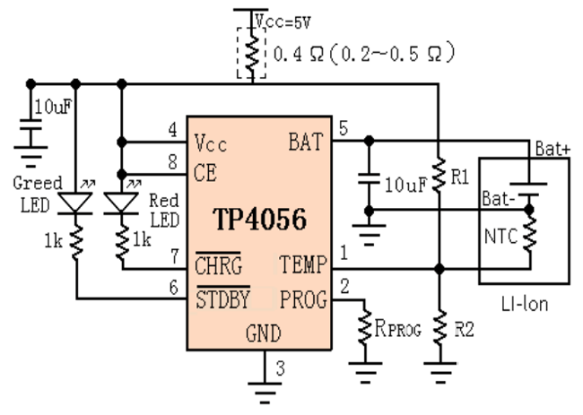It offers 1000mA charge current by default but it is **adjustable from 50mA to 1000mA by soldering a resistor.** The default resistor soldered in on the board is 1.2K Ohm.
* It is **recommended** that when you charge a battery, the current (in mA) offered by the breakout board is **37-40%** of the battery capacity (in mAh). For example, if you are charging a battery of 1000mAh capacity, you should adjust the resistance in a way that the current offered is approximately 370mA-400mA.
* Our Product uses the 300 mAh battery, so we must adjust the current accordingly:
  + - **111mA-120mA**
* Using the following table of resistance and current values to solder the right resistor to obtain the required current:

|  |  |
| --- | --- |
| RPROG (k) | IBAT(mA) |
| 30 | 50 |
| 20 | 70 |
| 10 | 130 |
| 5 | 250 |
| 4 | 300 |
| 3 | 400 |
| 2 | 580 |
| 1.66 | 690 |
| 1.5 | 780 |
| 1.33 | 900 |
| 1.2 | 1000 |

**So we must use the 10k resistor instead of the 1.2k resistor in our circuit**

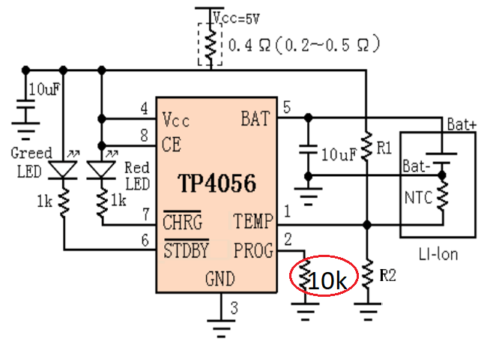

**FULL SCHEMATIC:**

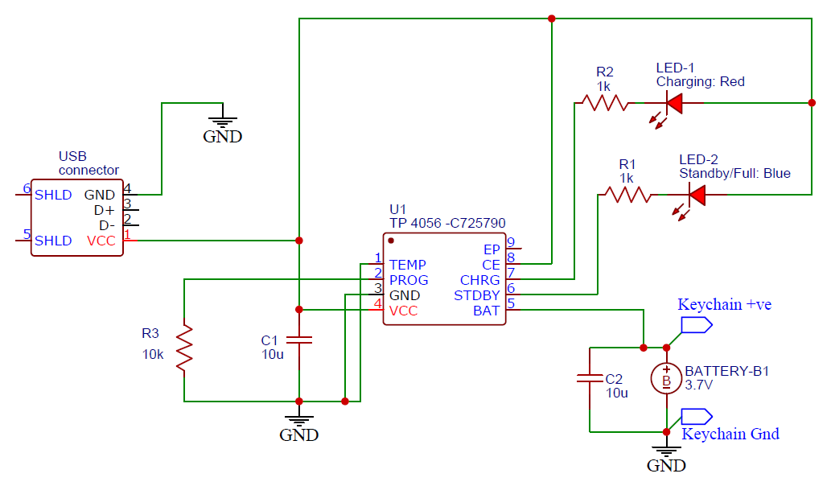

REFERENCES:

1. What is the charging voltage of 3.7V lithium battery: [What is the charging voltage of 3.7V lithium battery? - Grepow Blog](https://www.grepow.com/blog/the-charging-voltage-of-3-7v-lithium-battery/#:~:text=The%20charging%20cut%2Doff%20voltage,attention%20to%20the%20charging%20time.)
2. Datasheet: [复件 tp4056_42_English_空页脚.doc (haoyuelectronics.com)](http://www.haoyuelectronics.com/Attachment/TP4056-modules/TP4056.pdf)
3. How to build the circuit: [How to use Micro USB 5V 1A Lithium Battery Charging Board/ Charger Module - BuildCircuit.COM](https://www.buildcircuit.com/how-to-use-micro-usb-5v-1a-lithium-battery-charging-board-charger-module/)